**IDI – Interaction Design (I)**

**Understanding the fundamentals of basic interaction in UI**

***Background (Information Theory):***

* Analysis of transmission of electrical signals for telegraphic communication.
* Shannon Entropy measures:
  + The amount of informations to be transmitted by a message.

Elements (telegraph) of information theory:

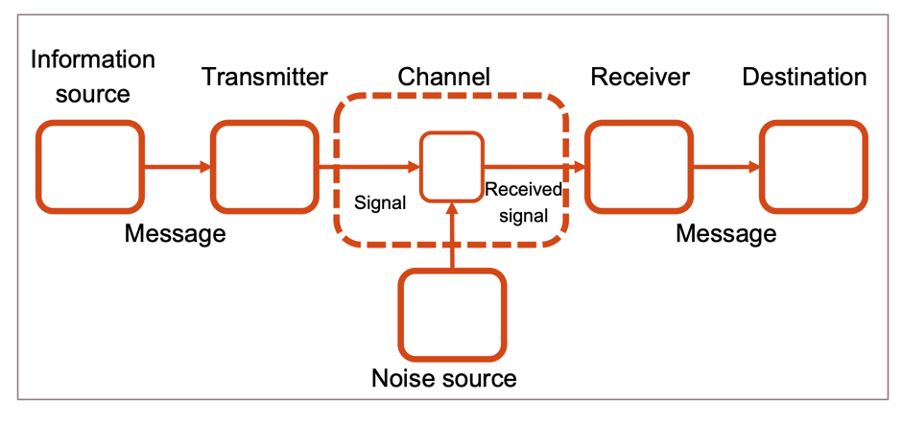

* Information source: The element that produces a message or sequences of message.
* Transmitter: Operates on the message to make it transmissible through a medium.
* Channel: The medium that transmits the message.
* Receiver: The element that reconstruct the message to the destination.

Information measures:

Let *d* be a device that produces symbols A, B, C and D with the same probability:

* M = 4 is the total number of symbols.
* Each time a symbol is produced we are uncertain on which symbol is going to be generated:
  + This uncertainty is not so big, since there are only four possibilities.
* The uncertainty is measured by log2(M) → here log2(4) = 2 bits.
* Logarithms are commonly taken in base 2, and the units are bits.

Example 1: Let *d* be a device that produces one single symbol: C

* M = 1 is the total number of symbols.
* We have no uncertainty and log2(1) = 0.
* The probability of getting the symbol C is 1.
* We previously know which symbol will appear!

Example 2: Let *d* and *e* be two devices, one with outputs A, B, C, and the second with outputs 1, 2.

* We combine *words* by concatenating one symbol of device d and one with device e.
* We will have 6 different words: A1, A2, B1, B2, C1, C2.
* 6 symbols → uncertainty of log2(6) → log2(2) + log2(3) = log2(6).

The uncertainty of combined the signals of a set of devices is the sum of their uncertainties.

For M symbols with equal probability → each symbol has probability P=1/M.

* Rewriting the uncertainty:

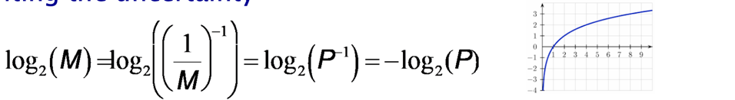

* -log2(P) is called the *surprise* or surprisal of finding a certain symbol.
* We will use pi from now on for the probability of a symbol i.

For M symbols that have different probabilities, we may have a different pi for each, provided that:

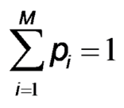

Information is the reduction of uncertainty or average surprise of a set of symbols:

* Measuring the surprise for an infinite set of N symbols (produced by a device) → the frequency of each symbol transforms to the probability.
* Shannon Entropy measures the amount of information:

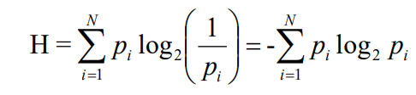

* + N is the number of alternatives.
  + *pi* is the probability of the iterative i alternative.
  + H is the entropy of the message that is to be transmitted, → the amount of information expected to be received (no noise).

Example 1: Source with two equiprobable symbols: A and B:

* p(A)=0.5, p(B)=0.5.
* H = -0.5 log2 (0.5) - 0.5 log2(0.5) =- log2(0.5) =- log2(2-1) = 1

→ The source requires an average of 1 bit per symbol.

Example 2: Source with two symbols: A and B:

* p(A)=0.1, p(B)=0.9.
* H = -0.1 log2 (0.1) - 0.9 log2(0.9) = 0,332 + 0,137 = 0,47

→ The source requires an average of 0,47 bit per symbol.

p(A) = 0.1, p(B) = 0.9

H=0,47 bits → Is it possible? We can achieve it using a smart codification of the information. For instance:

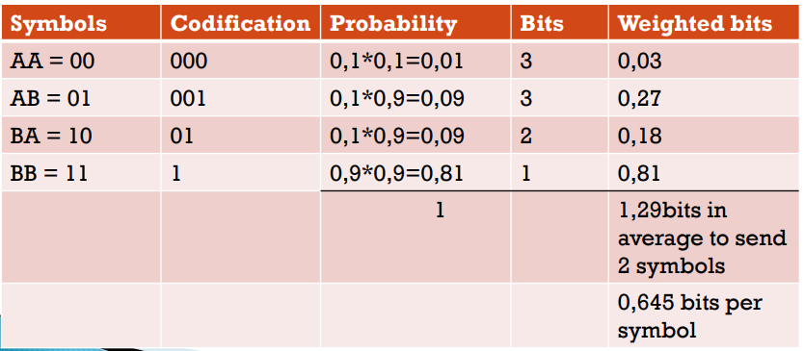

Shannon entropy:

* There is interference: Not all information will reach the receiver.
* Average information faithfully transmitted (R):



* Hy(x) is the equivocation or conditional entropy of x when y is known. Measures the information required to quantify the error.

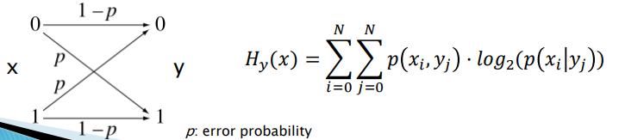

***Hick-Hyman Law (Measuring Choice-Reaction Time):***

* Describes human decision time as a function of the information content conveyed by a visual stimulus.
* It takes longer to respond to a stimulus when it belongs to a large set as opposed to a smaller set of stimuli.

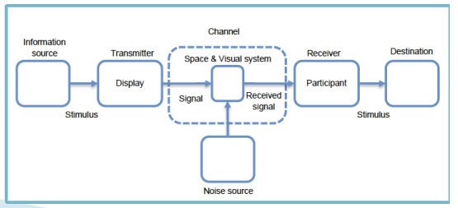

Time to make a decision (Reaction Time):



a, b constants.

HT transmitted information.

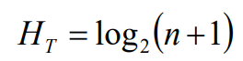

n is the equiprobable alternatives.

original formulation did not have the “+1” attends for the uncertainty whether to respond or not.

Time to answer is the Reaction Time:



Hyman [Hyman53] found that it also holds for not equiprobable alternatives.

Evidences of Hick-Hyman Law:

* Performance in hierarchical full-screen menu selections is well described by Hick-Hyman [Landauer85].
* Selection times decay logarithmically with menu length for frequently selected items, but linearly with infrequent ones [Sears94].
  + Learnt locations (most frequent) fit Hick-Hyman decision times.
  + Non-learnt locations fit a linear search.
* Novice users search linearly while experts decide upon item location and fit a Hick-Hyman curve [Cockburn2008].

***Fitts’ Law (Measuring Pointing Time):***

Original Formulation:

States a linear relationship between the movement time (MT) and task difficulty:

MT = 𝑎 + *b* ID

Formulation is also based on Information Theory:

* Amplitude of movement is the signal.
* Human motor system is the communication channel.
* Target width is the noise.

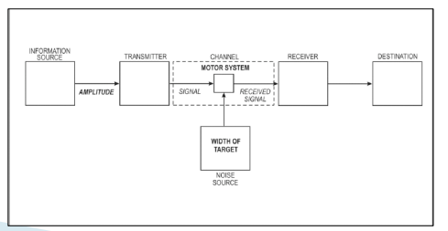

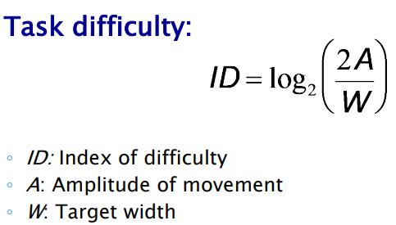

* The larger the amplitude the higher the difficulty.
* The larger the target the lower the difficulty.

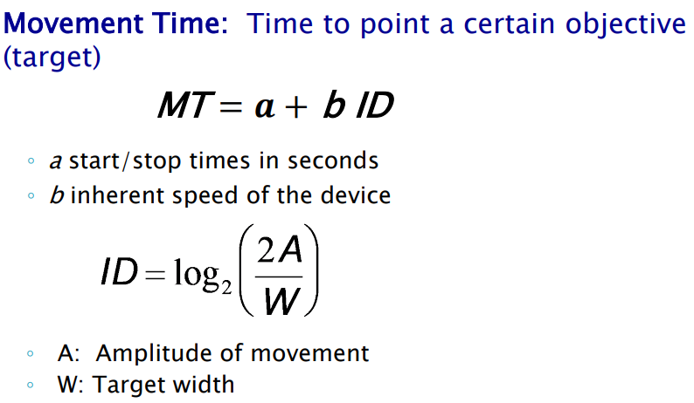

Experimental evidences:

Experiment 1: Reciprocal tapping:

* Participants used a metal-tipped stylus:
  + Two experiments with two different stylus: ~ 28.35 and 453.6 gr.
* Tap two strips of metallic targets of width from ~ 0.635 to 5.08 cm.
* At distance 5.08 to 40.64 cm.
* Participants instructed to be accurate!

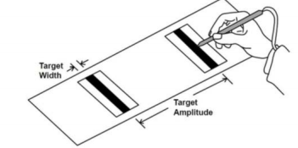

Experiment 2: Disk transfer:

* Participants had to transfer stack round plastic disks (with holes drilled through the middle) from one pin to another.
* Holes of different sizes and pins of different diameters used.

Experiment 3: Pin transfer:

* Participants had to transfer pins of different diameters from a set of holes to another set of holes.

Results:

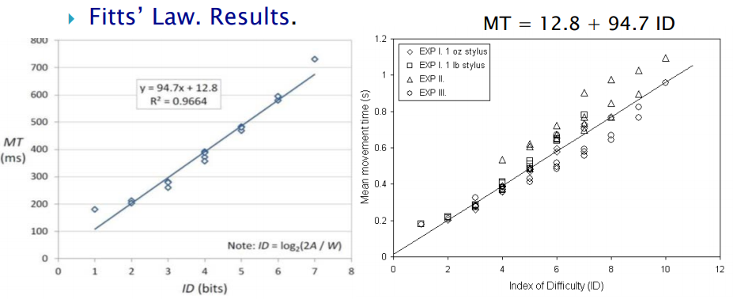

Results show that there is a linear relationship between MT and ID.

Most difficult condition: Smaller W and largest A.

Only valid for the experiments carried out.

* One curve per experiment fits better (different a and b values).

Variants:

Original formulation fits well to the original experiments:

* But it might fit better.

Other researchers have found different formulations that better model the experimental data:

* Including the experimental data by Fitts.

Welford [Welford68]:

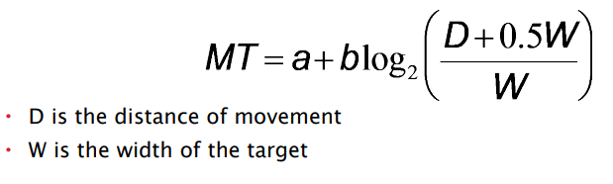

MacKenzie’s approach [MacKenzie92] is one of the most accepted:

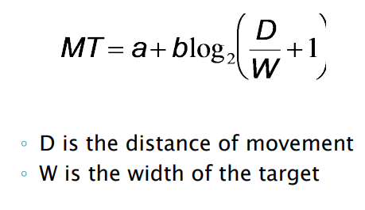

Vertical and horizontal movements can be treated equally:

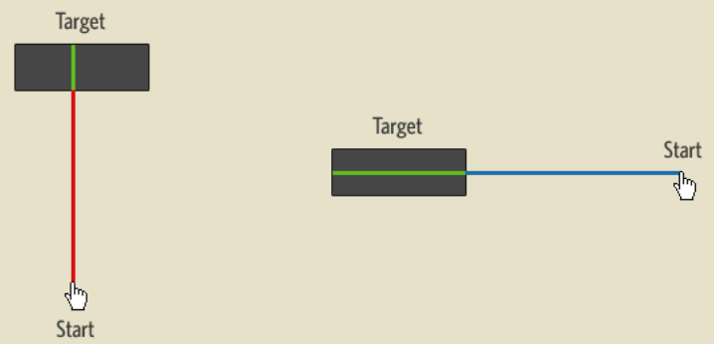

Extensions:

Main application of Fitts in HCI is evaluation/design of UI and interaction.

Today’s interfaces are much more complex:

* Variety of sizes.
* 2D movements.
* Use of fingers.

Use in UI design or evaluation:

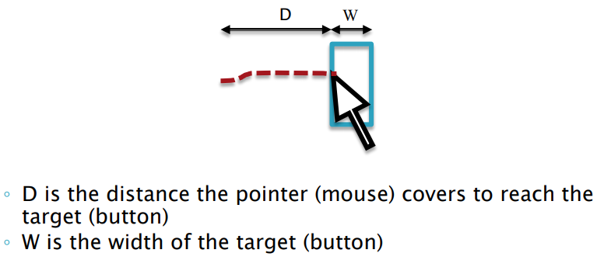

Extensions 2D:

Several extensions deal with 2D movements:

* Mimicking Fitts’ Law, but changing some of the parameters.

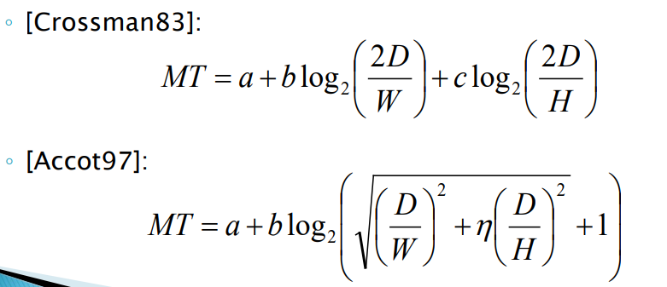

Extensions: precision pointing:

Fitts Law does not model properly very small targets:

* Extra time devoted to fine adjustment.
* Increase of errors …

Very small targets yield a lower fit of the regression curve of the MT function.

Touchscreens also modifies the timing we require to point targets.

Extension of Fitts’ Law by analyzing the behavior both in tactile screens and small targets ([Sears91]):

* Named FFitts (Finger Fitts), also PPMT (Precision Pointing Movement Time) by some other authors:

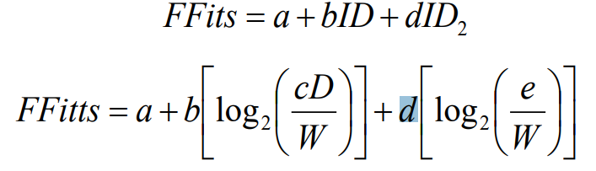

The higher number of freedom degrees, the easier to fit in a regression curve.

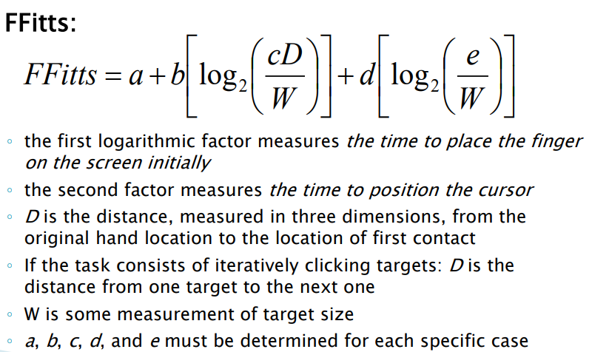

Assessed results:

Validation of Fitts’ Law may not extrapolate to outside the experiments carried out:

* Validity Fitts -> Experimentation.

Fitts’ Law have been formulated in a number of ways; however, its prediction is consistent:

* “the ID to acquire a target is function of the distance to and the size of the target”.

Fitts’ Law has shown its validity in multiple setups and devices:

* Mouse, joystick, finger, stylus…
* Different screen types of varying sizes…
* But the results cannot be extrapolated to data outside the experiment.

Validity Fitts => Experimentation.

Fitts’ law is a really good predictive model of human movement.

Precured targets lead to more efficient and precise pointing movements than for non-precured targets [Hertzum2013].

* Most common case: we know the buttons’ positions in advance.
* The benefit of precuring is larger for the mouse than the touchpad:
  + Maybe movement preparation is more effective if the device is more demanding.

***Crossing and Steering Laws: Continuous Gestures***

Law of crossing:

Crossing movement as compared to pointing.

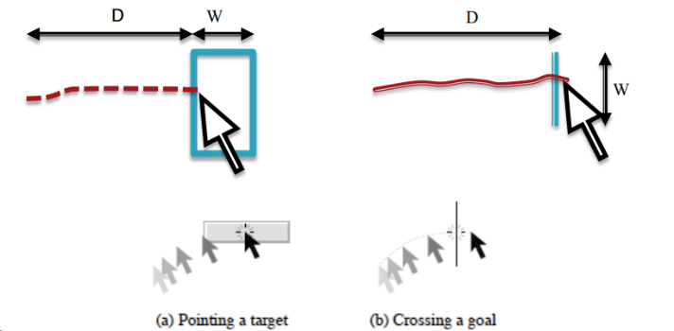

Crossing configurations:

* Discreteness vs continuity of the movement:
  + Landing and lifting off the stylus.

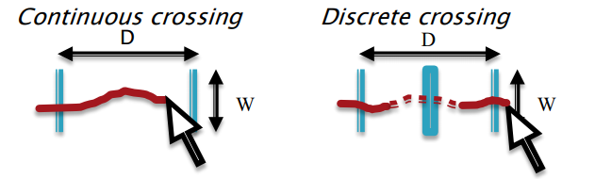

* Direction of the targets vs direction of the movement:
  + If parallel, the trace will be larger.

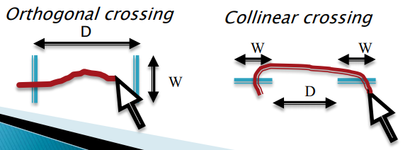

Stylus or fingers naturally lead to crossing gestures:

* Especially useful in tactile devices.
* Crossing an object is easier than double-clicking.
  + Drag & drop, multiple selections.

Crossing can be a good alternative for users who have difficulties with clicking or double-clicking.

Several objects can be crossed at the same time within the same gesture.

Crossing performance across two goals:

* Follows the same characterization than the Fitts’ Law:

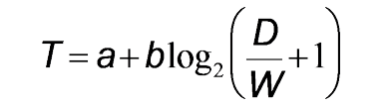

T is the average moving time between passing the two goals.

D is the distance between the two goals.

W is the width of each goal.

a and b are constants to be determined.

Results of the experiments:

* Crossing-based interfaces achieve similar (or faster) times than pointing.
* The error rate in crossing is smaller than in pointing.
* Discrete crossing becomes more difficult if the distance between the targets is small.

Steering law:

Navigating through a constrained path is an useful operation in modern UIs:

* Navigating through nested menus.
* 3D navigation.
* Dragging elements.
* Free-hand Sketching/Drawing.

Steering through a straight path:

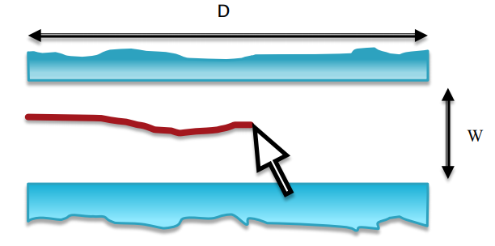

Navigating through a generalized path can be expressed as infinite crossings:

* Movement time across the path Ts:

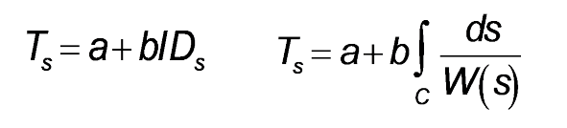

C is the length of the path.

W(s) is the path width at point s.

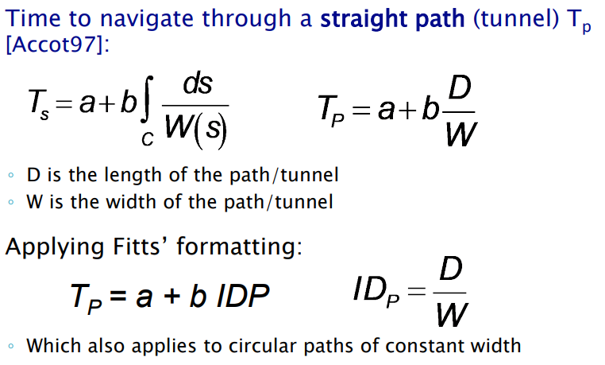

Results show that the steering law is applicable to different configurations:

* Different path shapes: cone, spiral, straight.
* Works with different devices, works in VR…
* Can be used to analyse navigation through nested menus, compare menu designs…

**Fitts’ Law in UI Design**

***Applications in UI Design***

Fitts’ Law accurately predicts pointing movement:

* Further distance => Harder to select.
* Larger target => Easier to select.

If improvement required, it can help us modify our UI:

* Change target width:
  + Increase size for faster reach.
* Change de “virtual distance” or pointer movement:
  + Increase speed, pop-up menus, ….

But visual stimuli must also be taking into account…

*The outer edges and corners*

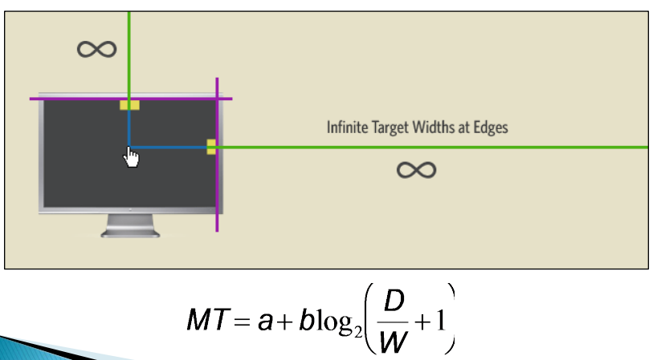

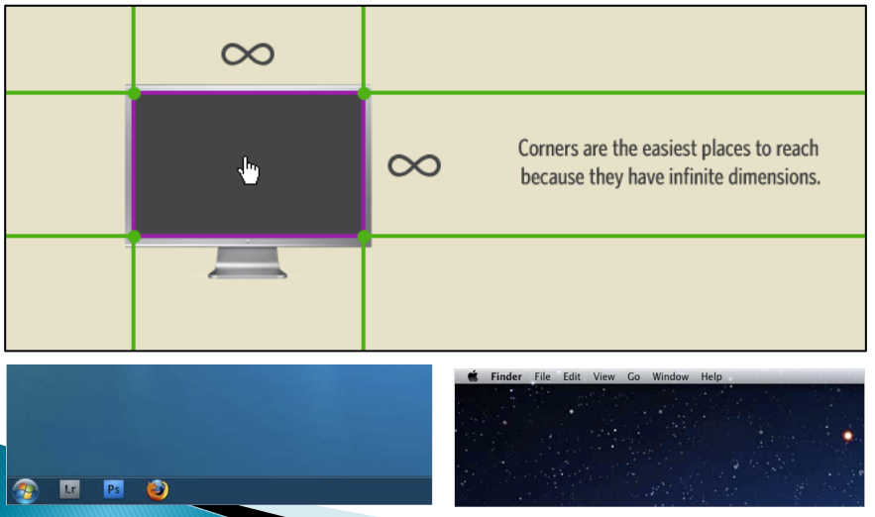

*Create larger target size*

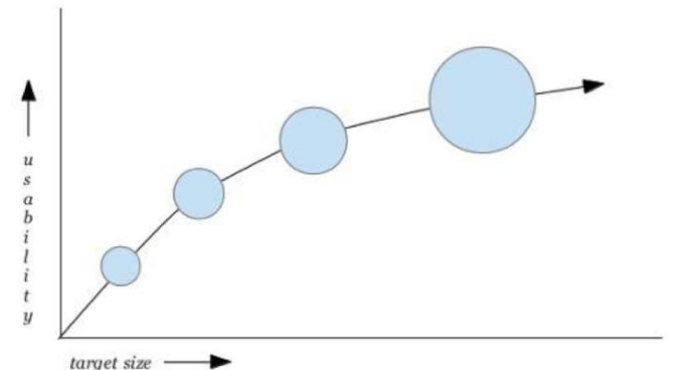

*Keep related things close and Opposite Elements Far*

* Filters should be placed close to the search field.
* These buttons should be placed far away from each other:



Pop-up menus:

Reduce travelling distance.

Improve two aspects:

* Reduction of distance to travel (Fitts):
  + The option is close to the menu emerging place.
* Frequency-enabled may improve the time to pick an option:
  + Based on Hick-Hyman: Recall that users are able to point faster objects that are known.

Only used by experts!

What about pie menus?

* Sort of contextual menu:
  + Needs to be created on demand.
  + Needs some room!
* Should not have occlusions:
  + On mobile half-pie menus better than fully circular.
* Difficult to design!
  + Second layer changes the size and distance.
  + Organizing by frequency may be a problem (learning).

+ Perception: Grouping things may improve over distance.



***Accelerating Target Acquisition***

Dynamic Expanding Targets:

*Increase the size of targets close to the pointer*. Two implementation approaches:

* Size-enlargement and position-changing icons.
* Enlarged icons overlap over their neighbors.

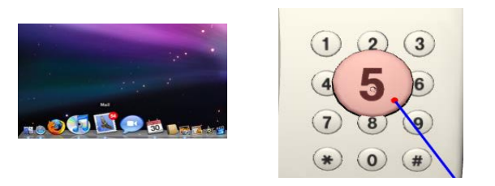

*Increase the size of targets close to the pointer*.

Exemple1: Implemented in Mac OSX Dock:

* Mix of target size increase and moving target.

*Enlarged icons overlap over their neighbors*:

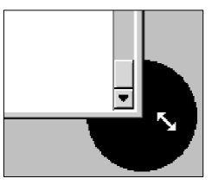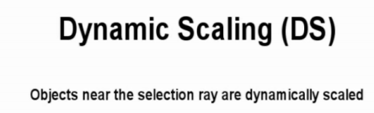

*Bubble targets*:

* Increase selectable region around target:
  + Only when the mouse is close.
  + Improves selection times.
* Issues:
  + Bubble appearing may distract users.
  + Overlapping targets: Close selection points may generate several bubbles.

*Bubble cursor* => Reduction of amplitude movement

* Cursor size increases when it is close to objectives.
* It may even grow to absorb the closer target when it is not completely inside the main cursor bubble.
  + Based on position, no speed.
  + In experiments Control-Display ratio fixed to 1.

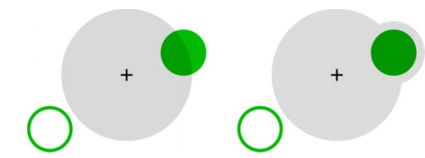

*Dynamic Bubble cursor*:

* Based on the Bubble cursor idea.
* It takes into account the speed of the mouse:
  + Area increases according to speed and position.
  + Visual cues to indicate the captured target: the target closer to the cursor center.

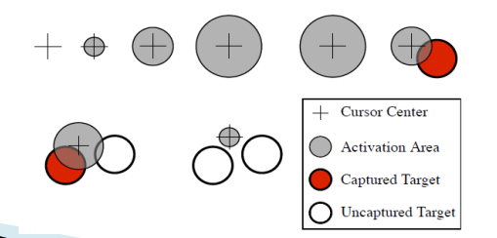

Target Moving:

* Move targets to the user.
* Generate targets next to the user: pop-up menus.

*Sticky targets*:

* Attract pointer.
* When the pointer is close to a selectable area.
* May reduce selection time: Precision not required.
* Users adapt easily.

Control-Display Ratio:

Relation between the amplitude of movements of the user's real hand and the amplitude of movements of the virtual cursor:

* Moves in real world (physical move) mapped to moves in virtual desktop (cursor move).
* Different strategies:
  + Constant.
  + Dependent on mouse speed.
  + Dependent on cursor position.
* Interpretation according to Fitts Law:
  + Dynamic C-D ratio adaptation can be interpreted as dynamic change of physical motor space.

Mac OSX and Windows both use mouse acceleration:

* When mouse moves fast, it is accelerated:
  + Reducing the amplitude of movement to cover large distances.
* When mouse moves slow, it is decelerated:
  + Magnifying amplitude of movement to improve precision.

No clear how the mapping affects perception and productivity:

* Some studies say it is not intuitive.
* Some studies say it improves some pointing tasks.

**EXERCICIS**

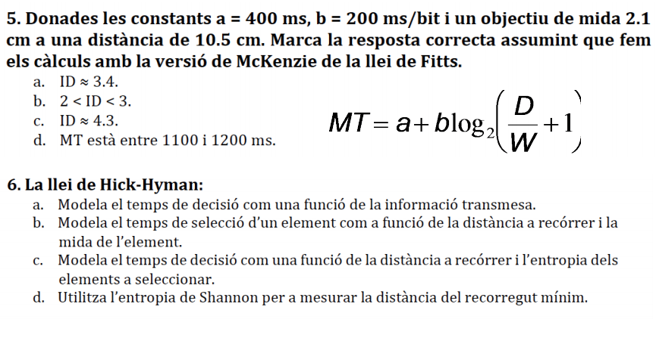

**Els expanding targets:**

1. Es basen en la llei de Hick-Hyman.
2. Pretenen reduir el temps d’accés als elements basant-se en el fet que, segons la llei de Fitts, el temps d’accés es redueix si s’augmenta la longitud del desplaçament.
3. Si es combinen amb el moviment dels objectius poden causar confusió a l’usuari.
4. Cap de les anteriors.

**Ens han encarregat fer un disseny d’una interfície per a un sistema tipus desktop en la qual hi haurà botons i menús drop-down.**

1. Podem predir la dificultat d’accedir als botons utilitzant la llei de Fitts i la dificultat de recórrer els menús amb la llei de crossing.
2. Podem analitzar el nombre d’elements a posar en un menú utilitzant la llei de steering i en funció dels digrames.
3. Podem analitzar el nombre d’elements a posar en un menú utilitzant la llei de Fitts.
4. Podem analitzar la dificultat de recórrer els menús utilitzant la llei de steering.

**La llei de steering:**

1. No es pot derivar a partir de la llei de crossing.
2. Serveix per modelar el temps necessari per recórrer un camí de forma arbitrària.
3. Diu que hi ha una relació logarítmica entre l’índex de dificultat de creuar un objectiu i el temps que requerit per a fer-ho.
4. Diu que l’índex de dificultat de creuar un objectiu és D/W.

**Dos elements T1 i T2 a distàncies D1 = 10 cm i D2 = 8 cm en direcció horitzontal i d’amplades 5 cm i 2 cm, respectivament. Per a T1 emprem un dispositiu amb a1= 200 ms i b1 = 200 ms/bit. Per a T2 utilitzem un dispositiu amb a2 = 200 ms i b2 = 100 ms/bit. Assumint la formulació original de la llei de Fitts:**

1. ID1 > ID2.
2. ID1 = ID2.
3. MT1 = MT2.
4. MT2 < MT1.